Data Visualization
Data visualization is the process of creating graphical representation of information. This process helps the presenter to communicate data in a way that is easy for the viewer to interpret and draw conclusion and make decisions.
Matplotlib
Matplotlib is a Python library for creating static, interactive and animated visualizations from data. It provides flexible and customizable plotting functions that help in understanding data patterns, trends and relationships effectively.
- Basic and low-level plotting library
- Highly customizable
- Foundation for many other libraries
Basic Types of Matplotlib Graphs
Line Plot
- Shows trends over time – Line charts are ideal for displaying how data changes over a continuous period, such as daily sales, monthly revenue, or yearly population growth.
- Helps identify patterns and changes – They make it easy to spot increases, decreases, peaks, dips, seasonality, and overall trends in data.
- Allows comparison of multiple data series – Multiple lines can be plotted on the same chart to compare the performance of different products, regions, or categories over time.
Code snippet and output:
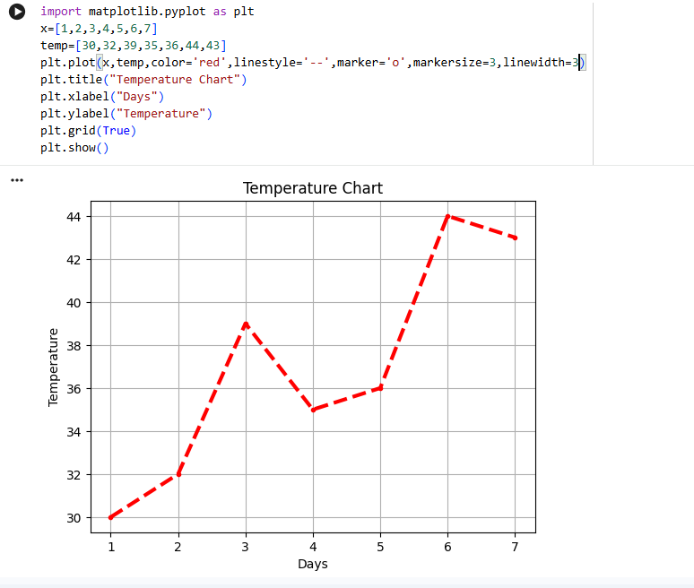

Description:
plt is shorthand used for writing code easily.
plt.show() Displays the final chart. Without this, graph will not appear.
we can change the line style, colour and its width to make it more attractive.
Bar plot
- Used to compare values across different categories.
- Easy to understand and interpret.
- Helps identify the highest and lowest values quickly.
- Widely used in business, education, and data analysis.
Code snippet and output:
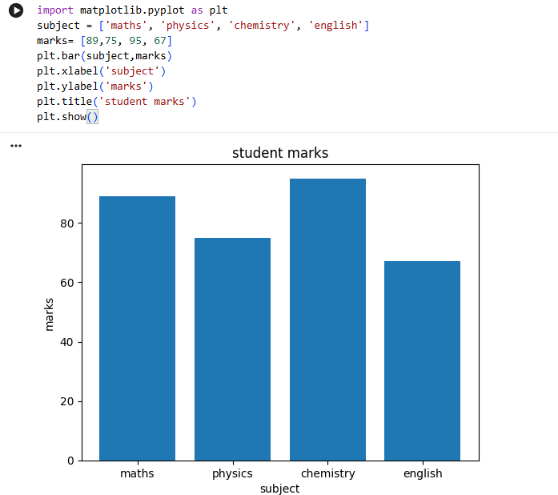

Description :
By this we can add make it more representable plt.bar(x, y, color='green')
Changes bar appearance, makes chart more visual and readable, you can use: 'red', 'blue', 'orange', etc.
Pie chart:
- Shows parts of a whole – Pie charts clearly display how each category contributes to the total, making percentages easy to understand.
- Easy to compare proportions – They help visualize the relative size of categories at a glance, especially when there are only a few categories.
- Simple and visually appealing – Pie charts are widely used in presentations, reports, and dashboards because they are easy for audiences to interpret.
Code snippet and output:

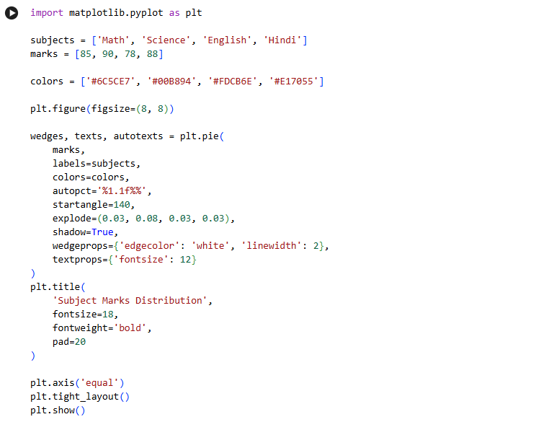

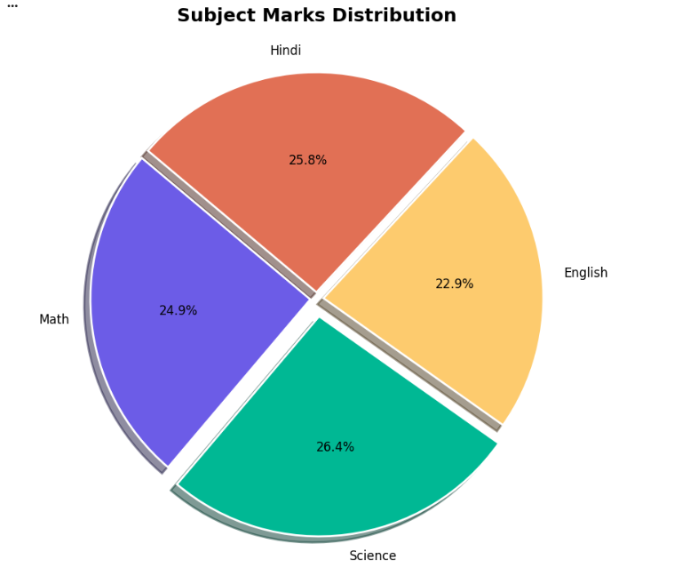
Description:
autopct='%1.1f%%',
- Shows percentages on slices.
- %1.1f means one digit after the decimal.
startangle=140,
- Rotates the pie chart.
- Makes the chart start at 140° for a better appearance.
explode=(0.03, 0.08, 0.03, 0.03),
- Moves slices slightly outward.
- Science slice is highlighted more (0.08).
textprops={'fontsize': 12}
- Sets label font size to 12.
Histogram
- Shows data distribution – A histogram helps visualize how data is distributed across different ranges (bins), making it easier to understand the overall shape of the data.
- Identifies patterns and outliers – You can quickly spot skewness, multiple peaks (modes), gaps, and unusual values that may require further investigation.
- Helps analyze spread and central tendency – Histograms reveal where most values are concentrated and how widely the data is spread, which is useful for statistical analysis and decision-making.
Code snippet and output:
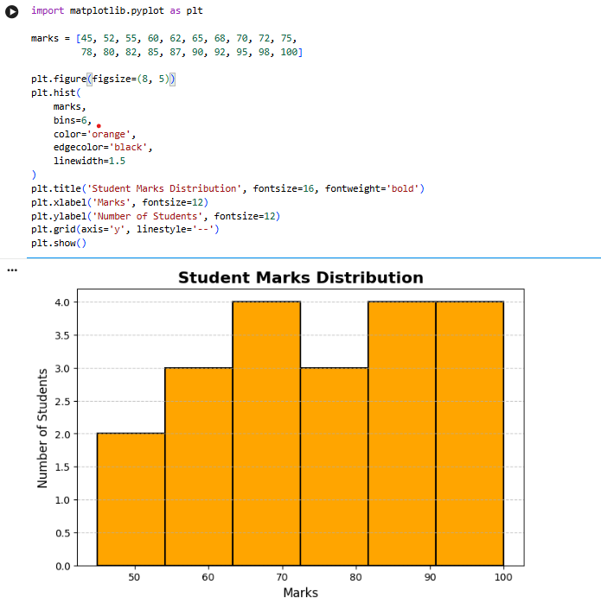
Description:
- figsize=(8,5) → Larger chart
- color='skyblue' → Pleasant color
- edgecolor='black' → Clear bar boundaries
- linewidth=1.5 → Thicker borders
- Bold title and labels
- Grid lines for easier reading
Scatterplot:
- Shows relationships between two variables – Scatter plots help visualize how one variable changes with another and are useful for studying correlations.
- Identifies trends and patterns – You can observe positive, negative, or no correlation between variables.
- Detects outliers – Unusual data points stand out clearly, making scatter plots useful for data analysis.
- Displays data distribution – It shows how data points are spread across the graph.
Code snippet and output:
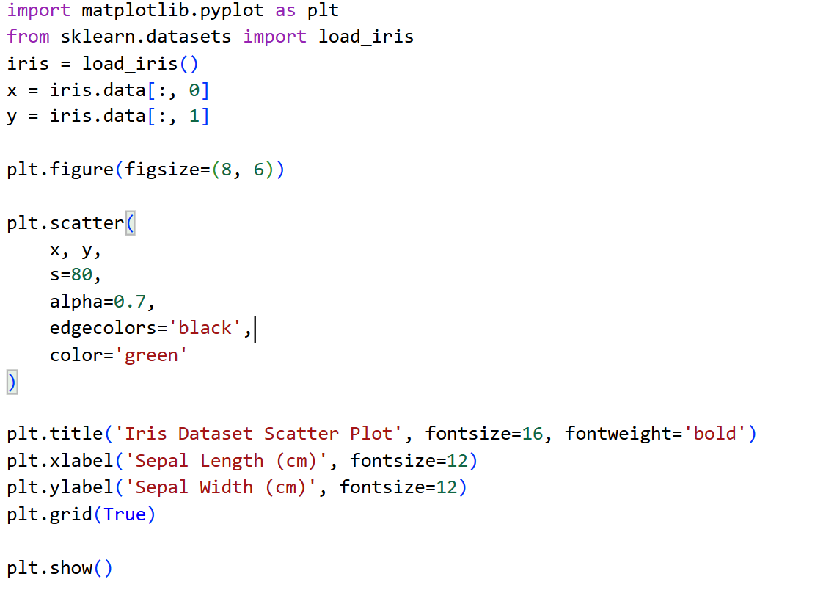
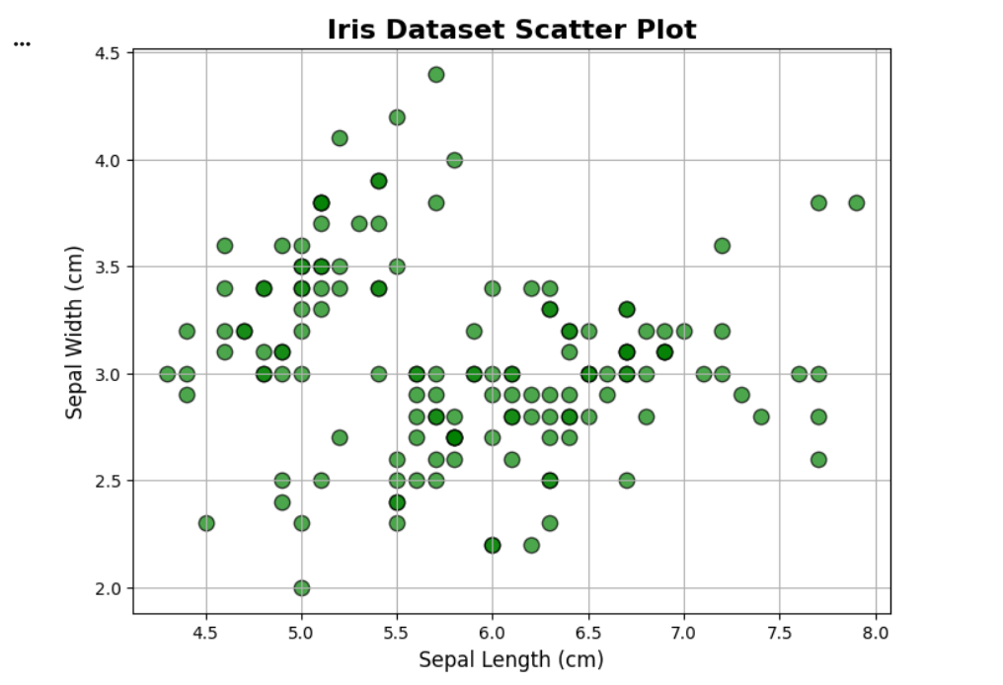
Description:
- iris.data[:, 0] → all rows of column 0 (Sepal Length).
- iris.data[:, 1] → all rows of column 1 (Sepal Width).
- Each green dot represents one flower.
- X-axis = Sepal Length.
- Y-axis = Sepal Width.

Seaborn
- Seaborn is a Python data visualization library. It is used to create graphs and charts from data.
- Built on top of Matplotlib, so it provides more attractive and easier-to-create visualizations.
- Works well with Pandas DataFrames, making data analysis easier.
- Provides beautiful default styles and color palettes without much customization.
- Requires less code compared to Matplotlib for creating complex plots.
- Used for statistical visualization, helping analyze trends, relationships, and distributions in data.
- Supports many chart types, such as:
- Scatter Plot, Line Plot, Bar Plot, Histogram, Box Plot, Heatmap, Violin Plot
- Widely used in Data Science, Machine Learning, and Data Analysis projects.
Scatter plot:
They show the relationship between two numeric variables, where each point represents one observation in the dataset.
Code snippet and output:
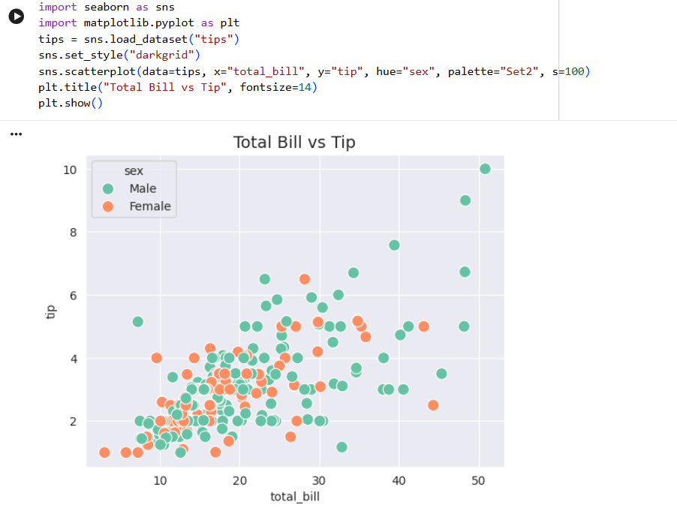
Description:
- sns.scatterplot() → creates scatter plot
- x="total_bill" → x-axis values
- y="tip" → y-axis values
- plt.show() → displays the graph
- darkgrid → clean background
- palette="Set2" → nice colors
- hue="sex" → coloured groups
- s=100 → bigger points (better visibility)

Heatmap
A heatmap is a 2D color-coded matrix where each cell value is shown using different colors.
- Used to visualize relationships in matrix form .Common in:
  - Correlation matrices
  - Confusion matrices
  - Pivot tables
  - Any 2D numerical dataset
Code snippet and output:
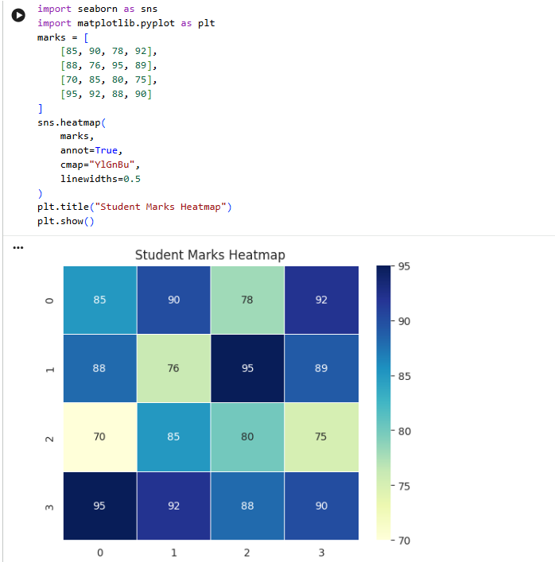
Description:
- annot=True → displays the values inside each box.
- cmap="YlGnBu" → applies a yellow-green-blue color scheme.
- sns.heatmap() → creates the heatmap.
- plt.show() → displays the graph
Violin plot
- Shows the distribution of data.
- Wider parts = more data points in that range.
- Narrower parts = fewer data points.
- Similar to a box plot, but also shows the shape of the data distribution.
Code snippet and output:
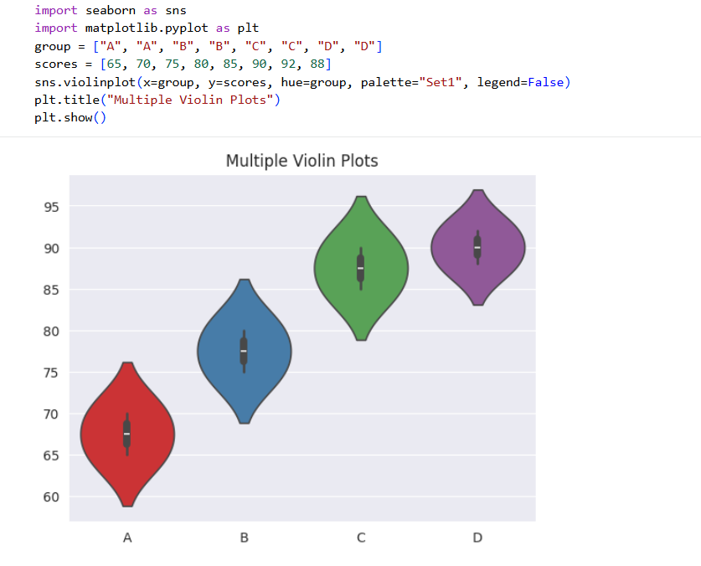
Description:
palette="Set1"
- Controls colors of violins
- Gives different colors for each category
hue=group
- Adds color separation
- Each group gets different color
- Makes graph more attractive

Box plot
- A box plot is a statistical graph used to show the distribution of numerical data.
- It displays data using quartiles and median.
- understand data spread
- To compare multiple groups of data
- To analyze data distribution shape
Code snippet and output:
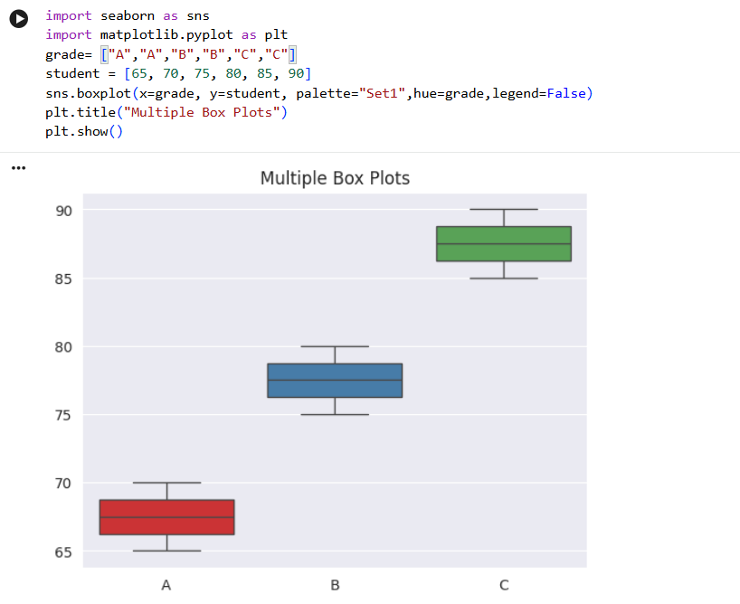
Description:
- palette="Set1" gives different colors to each box
- A box plot uses quartiles (Q1, Q2, Q3) to show data distribution, and the mean is the average value of the dataset.

Bar plot
- A bar plot in Seaborn is used to display the relationship between a categorical variable and a numerical variable.
- It represents the average (or other statistical estimate) of data for each category using rectangular bars.
Code snippet and output:

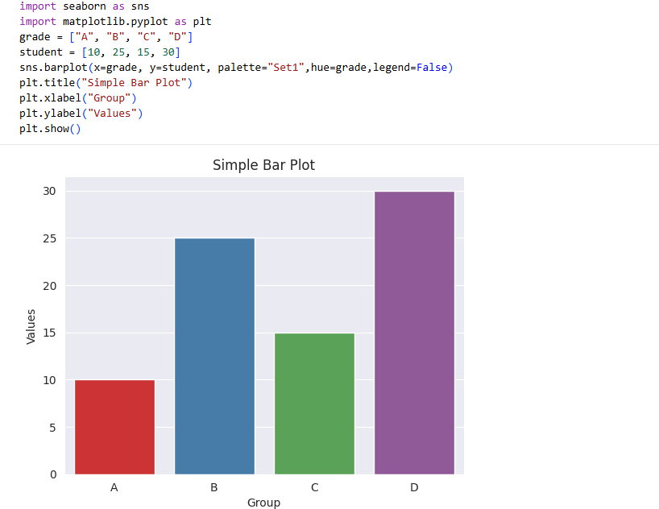
Description:
- x=group → categories (A, B, C, D)
- y=values → height of bars
- palette="Set2" → colors
- barplot() → shows comparison between groups

Difference between matplotlib and seaborn
Matplotlib
- It is a low-level plotting library in Python
- Used to create basic graphs like line plots, bar charts, scatter plots, etc.
- Requires more code and detailed syntax
- Gives full control over every part of the graph (labels, colors, styles, etc.)
- Default graphs are less visually attractive
- Works with arrays, lists, and basic Python data structures
- It is the base library on which many other visualization libraries are built

Seaborn
- It is a high-level data visualization library built on Matplotlib
- Used for statistical and attractive visualizations
- Requires less code and is easier to use
- Works directly with Pandas DataFrames
- Provides beautiful default styles and color themes
- Includes advanced plots like heatmap, boxplot, violin plot, pairplot, etc.
- Best for data analysis and machine learning visualization

